Part 1: Interview Questions (12 Questions)
Context: Conducted with the Production Manager Opera House Manager to gather in-depth operational and functional requirements.
A. Open-Ended Questions (3 Questions)
1.How do you currently handle conflicts when two different musical bands or performances request the same hall or studio at the same time?
Answer: "Currently, we rely on a manual paper logbook. When conflicts occur, the studio manager manually contacts both band leaders to reschedule, which often causes major delays, scheduling miscommunications, and customer dissatisfaction."
2.What are the main causes behind the loss or damage of high-value musical instruments in the opera house inventory?
Answer: "Because tracking is manual, instruments are moved between rehearsal halls without proper check-in/check-out signatures. We often don't know who last used a specific instrument or when it was damaged until weeks later."
3.How does the current paper-based ticketing process affect audience satisfaction during high-demand shows?
Answer: "Long queues form at the box office, seat selection is confusing, and manual cash transactions lead to accounting errors and slow revenue entry on show nights."
B. Closed Questions (3 Questions)
How many main performance halls and rehearsal studios are currently managed by the Opera House?
Answer: "We have 3 main performance halls (Main Hall, Small Hall, Open-Air Theater) and 5 rehearsal studios."
What is the average timeframe required to complete a full manual inventory check of all musical equipment?
Answer: "It takes approximately 4 working days."
What is the maximum seating capacity of the Main Opera Hall?
Answer: "1,200 seats."
C. Bipolar Questions (3 Questions)
Does the current system support online credit card payment options for ticket bookings? Answer: "No."
Do you agree that moving from paper contracts to digital archives will speed up musician onboarding?
Answer: "Yes, absolutely."
Is there currently an automated notification system to inform artists about rehearsal schedule changes?
Answer: "No, we inform them manually via phone calls or messaging apps."
D. Probing Questions (3 Questions)
(Following up on instrument damage): Could you explain more specifically which types of instruments are most vulnerable to damage or going missing during hall transfers?
Answer: "Portable high-value brass and string instruments, such as violins, trumpets, and customized microphones, suffer the most because they are easily carried between studios without immediate logging."
(Following up on paper ticketing issues): Why exactly do manual ticket sales lead to accounting errors on high-demand performance nights?
Answer: "Because cashiers process cash quickly under pressure to clear long queues, resulting in mismatched sold-ticket stubs versus cash register totals at the end of the night."
(Following up on schedule conflicts): What specific steps do you take when a band refuses to change their requested rehearsal studio time slot?
Answer: "The studio director has to intervene personally to offer alternative perks or reserve an off-peak slot, which wastes valuable administrative effort and creates tension."

Part 2: Web Form Questionnaire (10 Questions)
Context: Designed as a digital Web Form for broader audience members, studio staff

https://docs.google.com/forms/d/e/1FAIpQLSeIYkHxJOfuSi1YxpvK0TMjXF5wW8k045dzrswTcY255OATIQ/viewform?usp=publish-editor
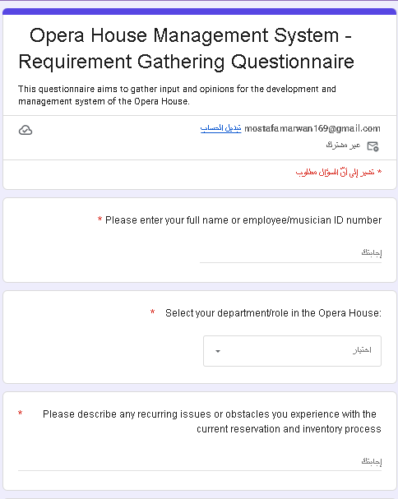
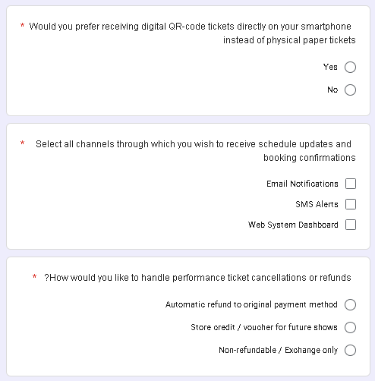
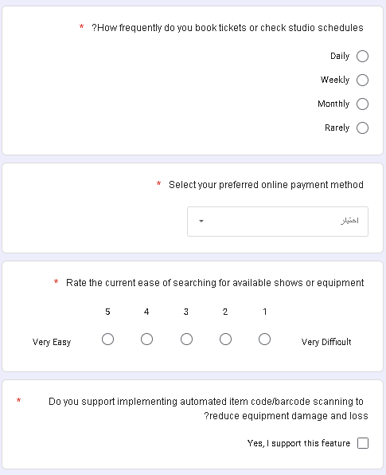

Part 3: Interview Report
Target Project: Opera House Management System
Interviewer: Systems Analyst Team (Marwan Mostafa Karam)
Interviewee: Production Manager / Studio Director
Date: October 2026
1. Interviewee Opinions
The Production Manager strongly believes that the current manual/paper system is inefficient and obsolete for modern Opera House operations.
In his opinion, manual studio scheduling directly leads to wasted time and idle studio hours.
He believes that automating instrument tracking via unique item codes is the single most urgent priority to prevent monetary losses due to lost or broken equipment.
2. Interviewee Feelings
Frustration: Expressed high frustration regarding hall booking conflicts and double-booked studio sessions that create unnecessary tension between musical bands.
Anxiety: Concerned about administrative errors during big seasonal events, especially ticket overbooking and paper ticket fraud.
Enthusiasm: Enthusiastic and eager about transitioning to a centralized web-based solution with QR ticketing and instant search features.
3. Current State of the System
Manual & Dispersed Records: Schedules, album arrangements, and contracts are recorded in manual physical ledgers.
Inventory Tracking Deficit: Instruments are counted manually without barcode/item code tracking, causing higher risk of damage/loss.
Ticketing & Sales: Ticket sales are completely paper-based at physical box offices, leading to long queues and limited audience reach.
Customer Data: No centralized database exists to store audience booking histories or patron preferences.
4. System Goals
Centralization: Centralize all musician records, hall schedules, album cataloging, and customer booking histories into one secure database.
Asset Protection: Track all musical equipment by unique item codes to ensure fast counting, zero operational errors, and asset protection.
Digitized Ticketing: Introduce an online ticket booking portal with real-time seat selection, payment gateway integration, and QR-code validation.
Resource Optimization: Eliminate schedule conflicts for halls and rehearsal studios to maximize resource utilization and increase overall revenue.

